**TOPIC- Operating Systems**

**Look at the pictures below and discuss the following questions**

1. What do you know about the development of computer operating systems?
2. Can you name all the Windows OS’s?
3. Why do some people prefer various types of mobile operating systems?
4. Which OS’s are the most secure? Why is that?
5. Which operating systems are most popular in the field of various ‘smart home devices’?

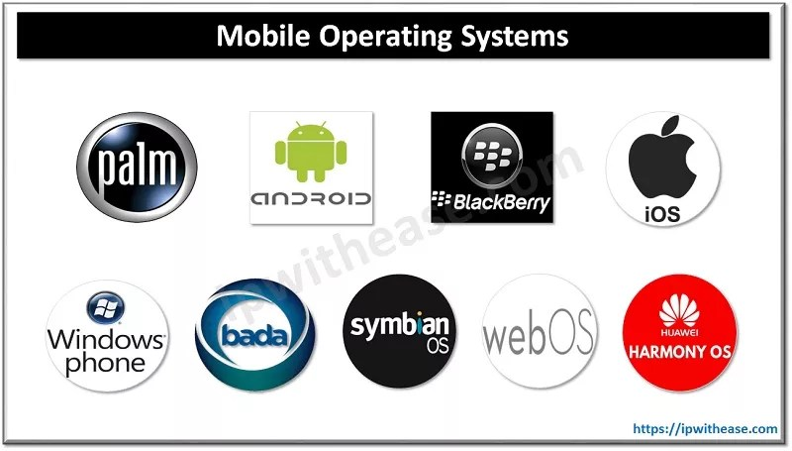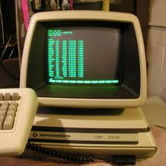

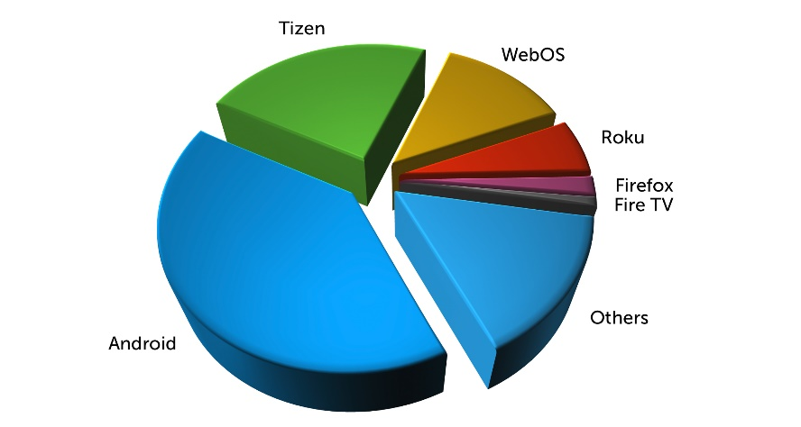

**Academic Article- Comparison of Mobile Operating Systems**

Open the ACADEMIC ARTICLE in MOODLE.

If you haven’t already read the article skim through it now, and write notes on the following questions. (Abstract, Introduction and Conclusion)

1. Who are the Authors of the article?
2. What is the general topic of the article?
3. What year and where was the article published?
4. What is the aim of this study? (Abstract)
5. What is the rationale for the article?
6. Find sources from the article: what do they tell us about the topic background?
7. What do the authors hope to do after conducting their research / what do they hope their research will help with? (Conclusion/Contribution)

**Part 3- Data Collection**

There are four main functions of this paragraph.

* Participants
* Methodology
* Data types
* Ethics

**Using the following thesis statement and research questions, complete part 3 using the prompts to help you.**

‘The aim of the proposed study is to find out whether there are generational differences in Mobile OS preferences in Lithuania, and what some of the reasons for this may be.’

The focus of the research is represented in the following questions,

1. What is the reason you chose your current mobile device?
2. What are some of the benefits of each major mobile OS (Android, IOS, Windows, Blackberry)
3. What is a major drawback of each major mobile OS (Android, IOS, Windows, Blackberry)
4. What does your generation feel is the most important aspect of a mobile device?

**Participants- who you are going to ask**

* *In order to answer the research questions mentioned above, the following data will be collected from…*
* *The research will consist of an interview with one or two representatives from the…*

**Methodology- what you are going to do**

* *There will be four ______________ where the participants will be asked 10 open questions which relate to each research questions….*
* *The interviews will be held face to face or online, and will be recorded and transcribed. It will be a one-time interview which is expected to take approximately one hour and the….*
* *Closed questionnaires will be given to participants of the final two interviews in order to answer…..*

**Data Types- what kind of data you will find**

* *The ____________ are going to yield ____________ data, whereas _________________ data will be collected from the _________________ therefore this study will employ a mixed methods design*

**Ethics- do you need permission?**

* *Because I will be asking……..there will be ethical issues, therefore……*

**Part 4- Data Analysis**

There are three main functions of this paragraph.

* Qualitative data analysis details
* Quantitative data analysis details
* Sharing of Results

**Complete the paragraph below with your own ideas**

Qualitative data will be analysed by identifying and describing how the participants answer the asked open questions during the interviews and what points are raised in the focus groups/discussions/during feedback. The personal views of the participants will be known, which will help to understand the current situation in regard of mobile OSes in relation to the research questions. Opinions, similarities and differences will be elicited from the transcriptions in order to find patterns. Further Quantitative data will be collected anonymously and analysed through SPSS. This data will be presented as graphs showing the preferences of various generations when it comes to answering the research questions The research findings will be shared with the colleagues in the Faculty of Fundamental sciences.